A Throckley Happy Life

By

Ian Bell

Helped by: Pam; Jess; Victoria; Lesley; Peter and Lynn.

- Interwar Baby
In 1935, Newcastle was at the forefront of transport innovation. Trolley buses were introduced for the first time and remained in use across the city until 1966. Also LNER introduced its high speed Silver Jubilee service from London to Newcastle using the Gresley A4 Pacific streamline engine, famous to most as the style of Mallard. In nearby Sunderland, the acclaimed actor James Bolam, was born on July 16th.
1935 was also the year King George V and Queen Mary celebrated their silver jubilee; Malcolm Campbell set a new land-speed record just short of 485 mph; the driving test became compulsory ; Stanley Baldwin (Conservative) became prime-minister and Penguin books were first published.
On the technology front, cats eyes were introduced on Britain’s roads; radar was put to use and the Hawker Hurricane, later known simply as “Hurricane” had its maiden flight.
The clouds of the war to come were also beginning to form as Germany introduced conscription and in response to growing re-armament there, plans to triple the size of the RAF were introduced.
Meanwhile on July 14th in Newcastle….

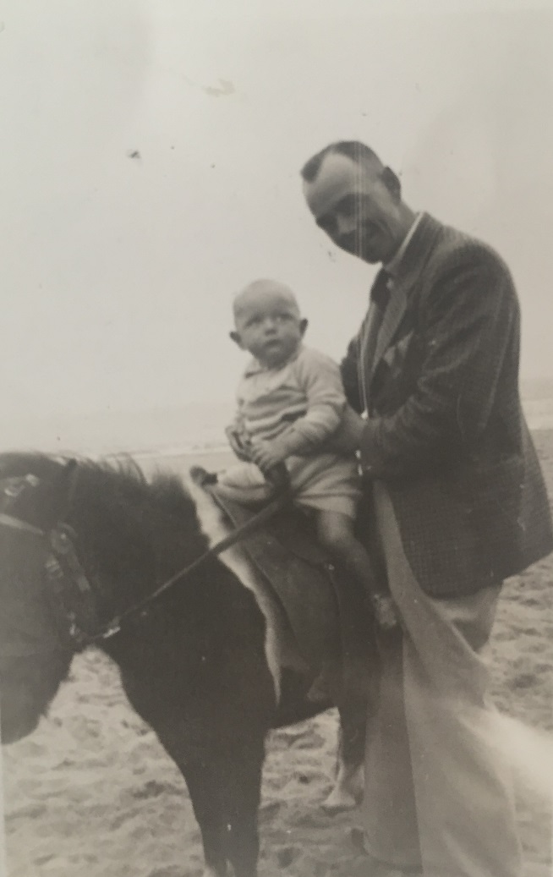
I was born in the Princess Mary Maternity Hospital, Jubilee Road, Newcastle. I am told I was an eye-watering 16lb when I was born and I was named: Ian Walton Bell by my parents William and Grace. My father came from Gateshead and my mother from Greenock, Scotland. Although my parents had two children, my younger brother, Robert, died at the age of 2 weeks, from a heart defect, so I grew up as an only child. Like any only child I was a little spoiled by my mum though she had very definite ideas about how I should grow up, signing me up for “The Blue Ribbon Club” at a very early age. The Blue ribbon was a symbol of the temperance movement. I am glad that I have never been expected to keep up with temperance.
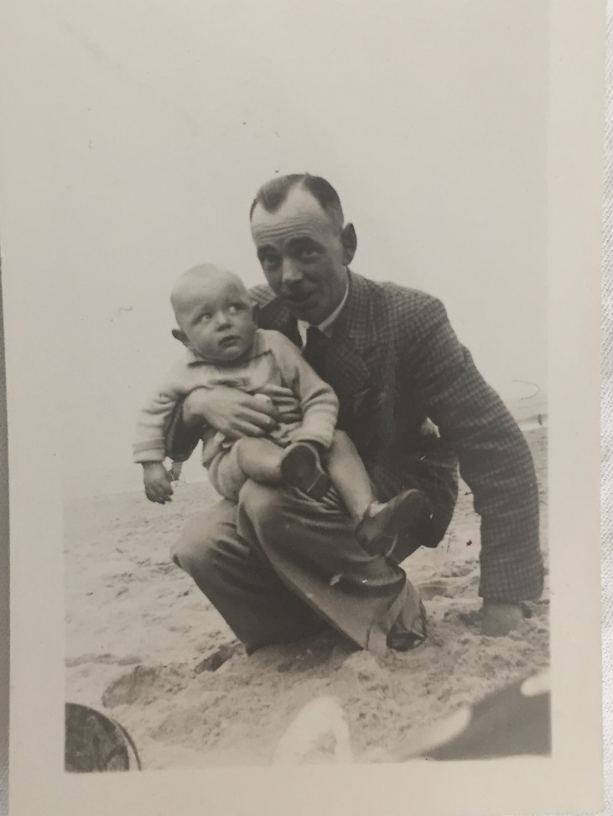
We lived in a rented house in Woodside Avenue, Throckley. Although my father was what would be termed an “entrepreneur” these days, he and his partner, George Brown, had had to borrow a lot of money to get their company “Newburn Cordage” a rope and twine business, off the ground. So although he owned his own company we didn’t live in luxury. I remember too, that my dad worked very long hours especially during the war when he was fire warden too, so we hardly saw him then. But I was still very close to him especially in our shared love of our team, Newcastle United. We were season ticket holders for lots of years and one of my fondest memories of my dad was being taken to matches.
Me on a Donkey in about 1936, I don’t look very happy do I ?

Me the bundle of joy again, there seems to be a pattern here?

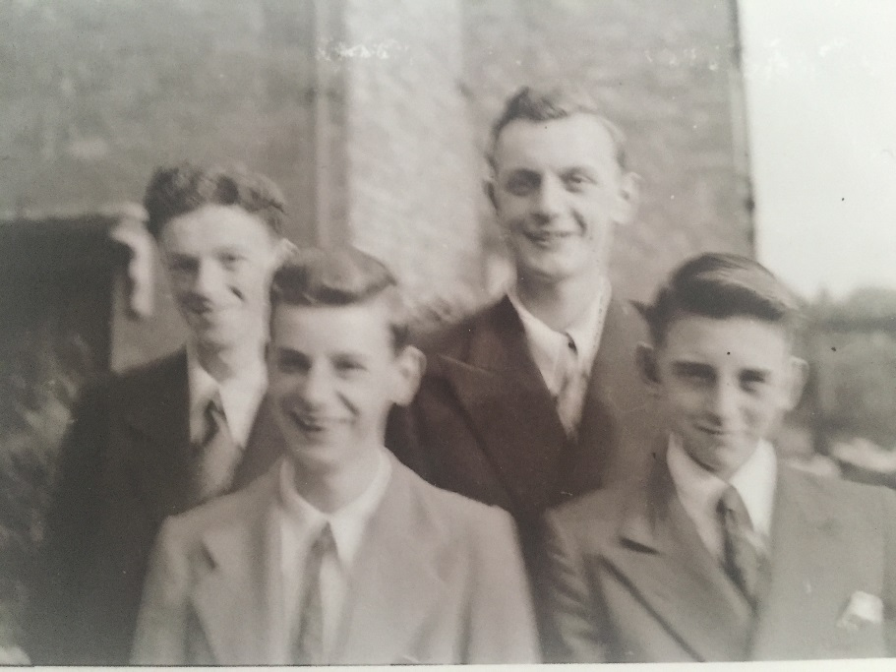
When I was 5 years old, double summer time was introduced to help the war effort, but for me it was a license to roam around in evenings, light until 11.30. We stayed out late in Throckley Dene- The Great Big Dene. The woodlands were our pretend world or just places to play or dare each other to undertake feats of imagined bravery. My companions in daring do were always the same: Gordon Walton ; Andrew McNeil and Peter Straughan . We were Throckley’s answer to “The Three Musketeers” or some might say “The Marx Brothers”, and I don’t mean Karl, either.
To say I was a mischievous child is probably an understatement. Wherever I went trouble seemed to follow. I wasn’t rude, defiant or anything like that, I just couldn’t, well, help myself.
Throckley’s answer to the Three Musketeers
I started school in 1940 and within two to three weeks had been noticed by the head teacher, Miss Jordan, not for my academic brilliance, but because I had had a fight with another boy and we had decided to sort out our differences by having a spitting contest. This was regarded as unacceptable by the head so we both were hauled into her office for a telling off and a strapping which was every bit as horrible as it sounds.
Mind you, not all my childhood injuries were self-inflicted. Throckley School had its own kitchen and it was the cook’s habit to sterilize equipment with boiling water which she regularly tipped out of windows afterwards, health and safety being non-existent in those days. One day I happened to be passing under the window as the waste hot water was being thrown and got my head scalded. There was no accident report or even a complaint, I just went to the medical room for a while and then back to class. No fuss was made by anyone. I didn’t even get an apology from the cook!

At secondary school we even made up a school song:

“Throckley School is a very good school,
It’s made of bricks and mortar
Who do you think runs the place?
The Baldy headed master!”
I was an experimental child, sometimes because I just couldn’t help myself, other times for devilment. There are many stories of me and my friends and what we got up to long before we had any sense of responsibility.
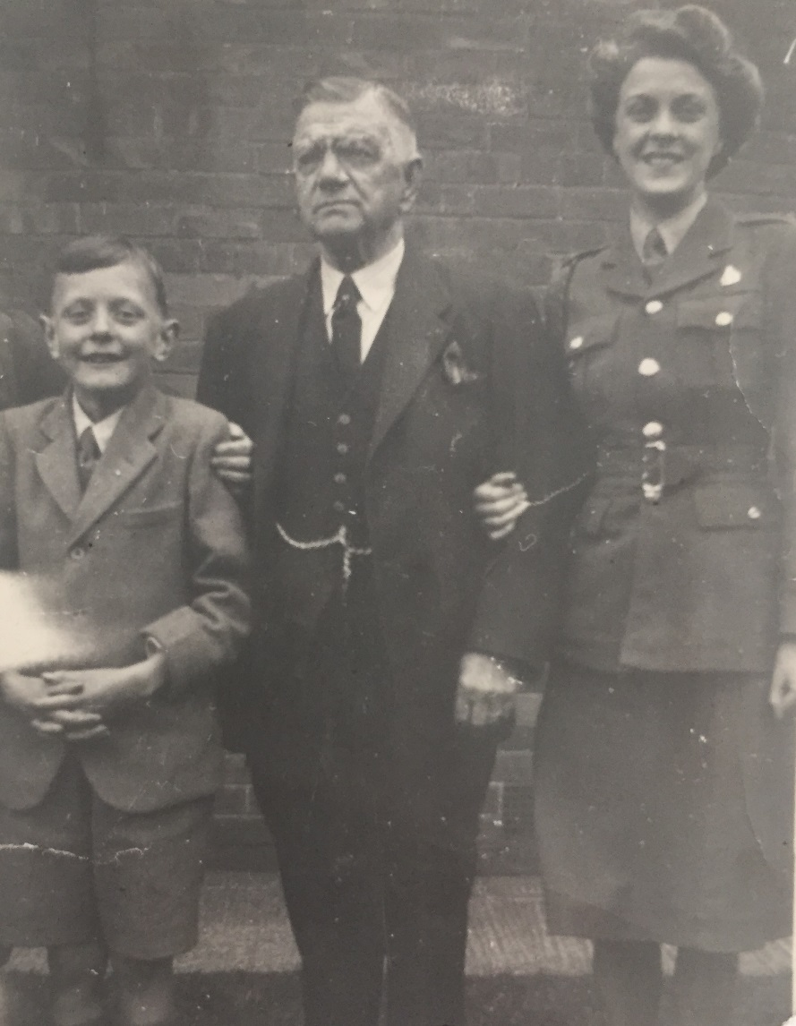
I was in the church choir and we used to get taken on trips. One of these trips we went camping for one week to Chillingham Castle near Alnwick and Chillingham village church. The war was over so I would have been around 12. People were still worried about bells being rung because during the war church bells were only to be rung at that time in an emergency such as threat of invasion. During our tour of the church a little hand, (mine) went out and rang the bell. The villagers’ heard it and were thrown into panic. They were not pleased at what I had done and I got into big trouble.
Later on I went on another trip, this time with school and it was an educational visit to the Co-operative dairy. It was a factory where milk was treated and put into bottles. Each part of the process was integrated and mechanised to produce hundreds of milk bottles a day. The bottles on a conveyor belt were topped off with paper lids which started life on a roll. I reached out and touched the lids on a roll which snapped, bringing the whole production-line to a halt. Needless to say a letter went home to my parents…
When I was a child we didn’t buy our milk in shops but it was delivered to our door and not in bottles either. Believe it or not our milkman was a dairy farmer from the fells called Jimmy Riddle, and received a lot of leg pulling just for his name alone. There is another reason though, why I have memories of him and his horse-pulled milk dray with churns on the back to which you took your jug to get milk. Forget the electronic games or a computer, we were outdoor lads and developed our skills in real life, not on a console. It may be impossible to believe nowadays, but there was lots of fun which could be had with just a forked stick and a tough piece of rubber. Yes, like many lads in my generation I had a catapult and one day I decided to test my skills on Jimmy’s horse, or rather his churns. I stood at a distance so it would be a challenge, I aimed and fired. The stone hit a churn and rang out like a bell. The horse bolted with Jimmy onboard. It was great fun and I don’t think I got caught for this particular misdemeanour.
I dread to think what would happen nowadays if playing cricket in the street a child hit a cricket ball at a window and broke it. At the time it seemed a very tricky situation, but we managed to sort it out in the community, not like nowadays when I am sure the police would be called and I would end up with an ASBO or something. Anyway I digress, we used to play cricket in the street and one day I hit the ball hard enough so that it hit the window of an elderly couple, broke the window and sat there lodged in it. All the other lads who judged the ball would hit the window disappeared, seemingly before the ball struck, leaving me to face the music alone. With the cheek of the devil, I went and asked for my ball back. She asked “Where is it?” and I replied “stuck in your front window”. She followed us home saying her husband was very sick and had had a heart attack because of what I had done. I knew I would be in big trouble for this one and sat waiting for my parents to come in dreading the consequences. I made up my mind unusually, to tell my mum what I had done before I got collared by the old lady. My dad went down to their house to try and sort it out, but low and behold, the supposedly frail, sick, old man had had a miraculous cure and answered the door as right as rain. My dad was less hard on me because they had lied and scared us all.
My mum and dad had been out at the picture hall when the cricket ball incident had happened. Amazingly enough, Throckley, a small village had its own cinema, “The Lyric” which had nothing to do with music but, instead was a mnemonic: (L)et (Y)ourself (R)elax (I)n (C)omfort. I had some adventures there myself not least of which was with my mates, trying to get in without paying by leaving the gents toilet window open so the others could climb in. We were barred though, for an entirely different crime. In the pictures they sold “Eldorado Ice Cream”. We used to leave a bit in the bottom of the tub whisk it up and use our spoons to flick the liquid ice cream into the air in front of the projection beam causing the picture to have the effect of snow falling. The lights came on and I was frog marched out and told not to come back. I never told my mum for fear of the consequences but they found out when they wanted to take me to the pictures and were told I had been banned.
The cricket ball incident wasn’t my only run in with elderly neighbours. Our houses backed on to Throckley Dene and at the bottom of the gardens was a steep bank down into the Dene. Two doors down from us lived an old woman who wasn’t very nice to children. We decided to have our revenge by taking two of her heavy paving slabs and throwing them down the bank. Little did we know she was watching. She made us get a rope and haul them back up and put her garden to rights. It was back-breaking work. We never picked on her again as I recall.
Not all our escapades involved physical labour though, some brought out our more creative side but with equally punishing consequences. One summer’s day we were playing out at Gordon’s house on Woodside, when we discovered curlers and scissors and decided to play barbers. I being the eldest, was the barber, Gordon my assistant and Andrew, was the customer. Now Andrew had very thick, slightly wavy hair so when we put the curler in the front of his hair it got tangled and stuck. We couldn’t get it out so I decided to cut it out, taking with it a chunk of Andrew’s hair from the front of his head. At the end of the afternoon, Andrew went home to looks of horror from his mum who dragged him back to Woodside where Gordon’s mum gave him a wallop and for once, I got away with it. It took ages for Andrew’s hair to grow back properly, if indeed it ever did. Today he has more hair on his eyebrows than the front of his head!
For the time I guess our house would have been thought of as fine, we had a huge garden and a parlour which was only used on special occasions and contained a telephone used for my dad’s business, which was very unusual in those days. We had an inside toilet and one memory I have is that when grandad was staying with us once he had bought me a gun which fired sucker pads by means of an elastic band. During his stay I managed to fire it at the toilet wall and as I pulled off the sucker, it brought with it a load of plaster off the wall. I told my mum it was my grandad, hitting the wall with his pipe, how ungrateful was that?

2: Wartime Memories
Like All major industrialised cities and ports, Newcastle and the surrounding area took a beating from air raids during the early part of the war. Almost 50, 000 mothers and young children were evacuated being separated from their families. While Newcastle missed much of the devastating bombing given to Hull and Coventry, nevertheless thousands were left homeless, hundreds died or were seriously injured in the air raids which took place between 1939 and 1942.
Many local men were in essential wartime occupations and couldn’t go to fight, but those who went served their country, some like Throckley resident, Fred Jewett (born 1923), put their lives on the line time and time again, in the highly dangerous arctic convoys. Others, so many years later, are now just names on a roll of honour such as Pte A. Wakenshaw VC who was posthumously recognised for valour.
Many famous people visited the area to help keep spirits up and to raise funds for the war. Amongst the stars of stage and screen were actor John Gielgud and songbird, Gracie Fields. Mighty leaders too including De Gaul and Churchill came following crises as did the King and Queen, who visited twice.
Throckley being only a few miles from Newcastle, had its own drama too. On the night of 3/4th May 1941 a bomb fell on Throckley Dene creating a massive bomb crater and damaging local houses.
When you are in your 80’s people expect you to remember a lot about the war, but in truth I do not. I remember the effects the war had on my life and the fact that they seemed normal at the time because they were more or less all I had known. The War after all started when I was four and ended when I was 10.
The best thing for me about the war was double summer time, made so that work could continue longer into the night but for me it gave me extra time to play out in the Dene. The dene was the place which brought us as close to war as we ever would be in Throckley. I remember clearly the night the bomb dropped there and exploded. The woman next door and her husband had a proper Anderson shelter. We were in our bomb shelter which was just a little sandbag affair with a cloth over the entrance. My grandad was in the garden watching and he saw the bomb coming. He dived through the doorway to protect us. The whole place shook. Next morning we saw that some rooves had been blown off and windows broken but no one was hurt. The next day was Sunday and as was the custom we all went out for a walk on The Dene to look at the crater. A few days later when it had all cooled down me and my friends collected shrapnel from the site. I still have it now.
I don’t remember being hungry or going without, my mum somehow always managed to get me enough food, she used to give me some of her rations. But people locally developed some schemes to supplement their lifestyle. Gordon’s dad at sometimes kept chickens and still had the coop. During the war he tried to grow his own tobacco and was drying it in there. The climate here isn’t really good for growing tobacco, because the dried leaves just went powdery, but it was in short supply. One day me Gordon and Andrew decided to give this home-made bacci a go. We took some drying leaves from the hen coop, rolled it and lit it. Well, I have never been so sick in all of my life as I was then. It did me a favour though, putting me off smoking.
When the bomb went off in the Dene, my dad wasn’t with us because when the siren sounded for an air raid he had to go to the factory, he was an ARP warden. He told me that they had to learn the job before they were commissioned as wardens. The night they achieved their status, they went to celebrate at Newburn Off-License and this was the night the dairy caught on fire and they were all too much the worse for drink.
In the local area we had lots of Italian prisoners of war. They were housed in a camp up at Darras Hall, Ponteland. I remember their very dressy uniforms and the fact that they used to take local girls to the LYRIC cinema. There were so many of them that we sometimes couldn’t get seats and had to sit on the steps in the auditorium. There was no real safety checks in those days and if a bomb had dropped we would have been too over crowded to escape.
My favourite meal during the war and later was traditional Northumbrian leek pudding. This was a suet based pudding steamed in a basin for hours but it was so delicious, much better than some other food at the time. Although we were never short, my dad was too busy to “dig for victory” as everyone was encouraged to do. He worked many hours and often overnight because during the war his factory had become a manufacturer of camouflage netting. But even so we sometimes had a share of a pig which someone kept and would get sausages from time to time. Some people though tried to cheat. They would fill the meat pies with stale bread and gravy, pretending it was meat. It tasted awful. I remember people would try to get around the rationing of meat. There was this one bloke who kept pigs. He used to push a pram down the street. A policeman stopped him and found that instead of a baby he had half a pig in the bottom of the pram. I don’t know what happened but he must have got fined or something.
I was 10 years old when the war ended, but little did I know at the time that I too would have to join the services.

3: National Service
National service followed on from the war. From January 1949, all healthy males between the ages of 17-21, except those working in mining, farming or the merchant navy were expected to service for a minimum of 18months in one of the three armed services.
Several crises happened in the 1950’s including Suez, The Korean War and the Mau Mau uprising made it essential that we had a maintained armed service. Gradually though, from the beginning of 1957, National Service began to be scaled down, finally ending in 1963.

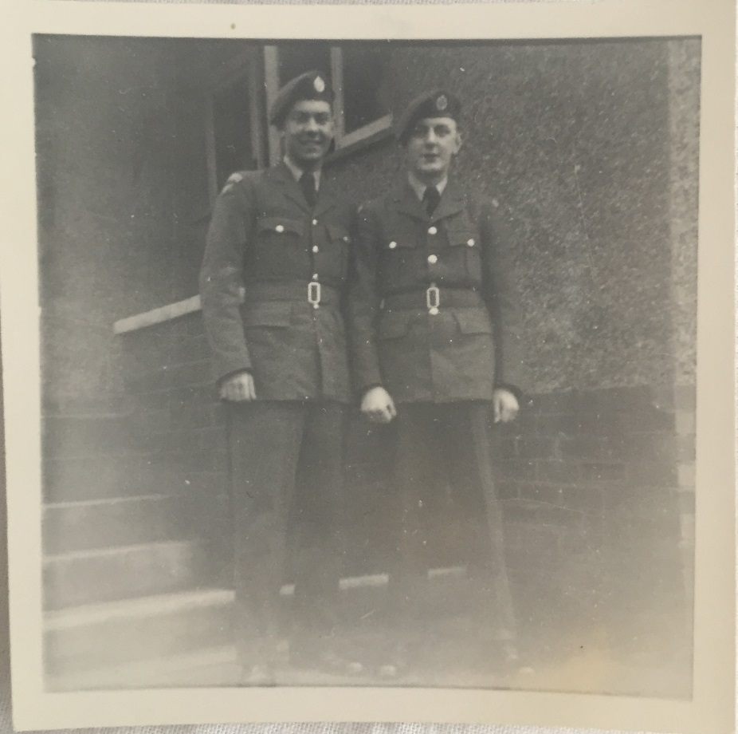
I was called up to serve with the RAF when I was 18 years old. It was expected, but it still broke my mother’s heart. I had never been away from home by myself before. I remember with a chuckle the sex talk I had with my dad just before I left:
“Well son, there’s good women and there’s bad women”
He didn’t tell me how to spot which was which, nor what I should do with them when I found out!
After a long journey south to Bedfordshire, I found myself along with other recruits, on the platform of the station where we were picked up by bus and taken to the RAF reception centre at Cardington. Cardington still had the sheds for the airships which for a time had been built to rival the German Zeppelins.
I remember that the food and entertainment there was excellent. There was method in their madness though. At Cardington you had to sign on for the trade you wanted to do. Some trades meant a longer national service. The aim was to persuade you sign on for a trade where you had to stay on longer. There was entertainment there, including their own dance band and a cinema too. If only the rest of national service had been like that.
From Cardington we were transferred to Padgate near Warrington. Before I went to Padgate I didn’t believe in Hell, but after 6-8 weeks basic training there I knew where Hell was – somewhere in Cheshire ! First off, we had to sit on the train from Cardington to Padgate all the way with our arms folded with sandwiches on our lap which we were not allowed to touch. When we eventually got there, matters didn’t improve at all.
We had to stand by our beds in our huts and the sergeant and lance corporals came it and gave us a lecture:
“You can forget your mothers now, I am your mother!”
He began and the talk continued for two hours. Some lads fainted but we were not allowed to go to them they had to lie on the floor till they came around. During the talk, he gave us all the rules and what we could and couldn’t do. It was very strict and there were loads of punishments for those who didn’t meet his exacting standards. Some of them were quite humiliating.
Each morning you had to stand by your beds with your kit laid out for inspection. One morning there was this one lad. I felt quite sorry for him. His kit wasn’t laid out quite neatly enough and the sergeant up-ended his bed and tipped it all over the floor. For this “crime” his punishment was to clean the toilets with a toothbrush which wasn’t only humiliating it was disgusting and smelly too.
So, after the lecture from the sergeant we knew what we had to do. We went in search of cardboard which we could put inside our shirts, towels etc.. So that we could lay them out flat and keep them crease free. We also had a peculiar way of making our boots shine so that you could see your face in them (but don’t try this one at home!). We got a red-hot poker and burnished the surface of the leather all over, but particularly at the front. Then we would rub in polish and spit to bring up a mirror shine. When doing the burning, it was particularly important not to burn the stitches of the boots otherwise you would suffer and have to buy a new pair of boots.
There were some strange goings on at the camp which you would never believe actually happened, but they did. Firstly we actually had to wash the coal and then paint it up so that it looked black enough. Then as if that were not bad enough we had to paint all the curb stones white and if it was particularly dry and the grass lost its colour we had to paint that green too. These tales make it sound more like a scene from “Alice In Wonderland” than the Royal Airforce but there was one thing I learned from all of this cleaning and painting, appearances mattered.
Because this was the mid 1950’s and many were off fighting elsewhere, the RAF was down on numbers. This meant that after our basic training we got up to Scotland, to Dumfries to be precise. I wasn’t unhappy about this as it was easier to get home to Newcastle from there. At Dumfries we were given combat training. We did assault courses and learned how to maintain and use all kinds of armaments. There was one hapless lad who, when learning to use a grenade, pulled out the pin and threw it but kept hold of the grenade. We all, including the chap (Minus the grenade) dived behind a barrier and heard/ felt the massive explosion which live grenades can make. It was hard, physical work but trained us well except for one essential skill that was, marching.
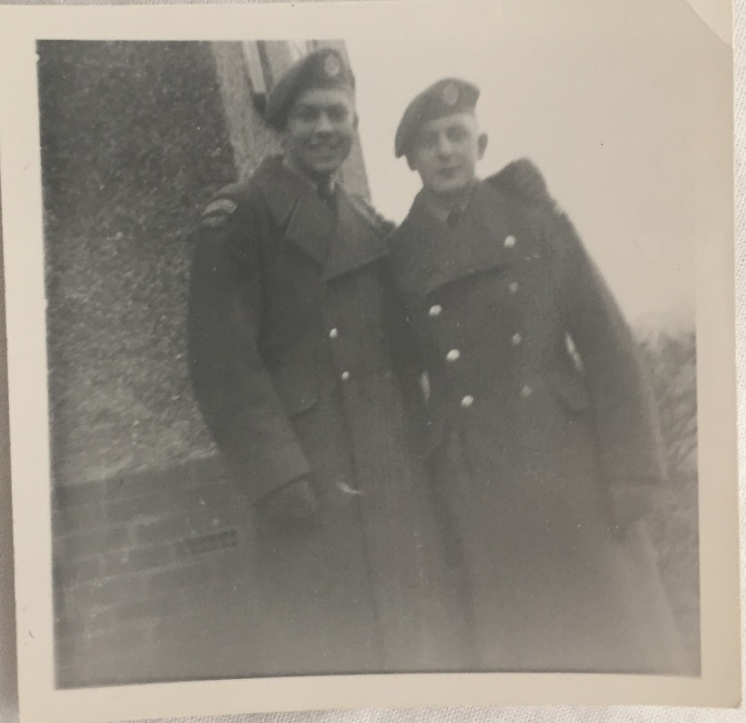
The Armistice Day Remembrance Service for that year took place while we were at Dumfries. Accordingly, we were on parade and had to march through the town centre. We had not trained together as a troop and were appalling. It was considered by the NCOs to be a shambles, so we were confined to barracks for two weeks and all leave was cancelled. During that time we had to practice drill routines again and again. Ironically. As a group, we were never likely to need to be on parade again as it would be a different group of soldiers next time. The cancelling of leave hit me hard more than the others as I was planning to go home for my leave.
From Dumfries I was transferred to Weeton near Blackpool for my professional training. I had chosen to be trained as a “gunner/Driver”. I passed the car test easily but it was during my training on wagons that I hit a problem. We had to drive through Blackpool in heavy traffic during the middle of the holiday season. I lost control of the truck and it mounted the pavement. Fortunately no one was hurt. The sergeant instructor took the wheel off me and drove back to base where I was called in to see the officer in charge. I was told I had failed the course and it was no longer possible for me to complete my training.
Now failing your profession in the RAF should have made me feel bad or ashamed, but I knew I had a good job waiting for me upon discharge and secondly, they sent me back to heaven – Cardington, where my journey in the RAF began! I was to be part of the team which processed young RAF troops starting out on their National Service, just as I had done the year before. I was as happy as a pig in mud! The food! The entertainment! The easy life!
For anyone who knew me before my national service they would have hardly recognised me on discharge. When I enlisted I was a skinny slip of a lad weighing 10st. By the time I was discharged 18 months later, I weighed in at 14st 10lb. I would like to say it was muscle but I would be lying. It was most definitely the food. Every morning we ate a full English Breakfast… Then mid-morning we had tea and cakes. Then lunch followed by afternoon tea which was followed in the evening by a cooked tea. The work too was far less physically demanding than the other places I had been stationed too.
Lots of young RAF servicemen passed through Cardington while I was there. I saw a fair few deadbeats and conscientious objectors too. They were told to put on the uniform and many refused to put the uniform on or swear the oath of allegiance to the queen. Each would be asked three times to take the oath and on the third refusal they were court-martialed. Some of them, especially those who had religious objections volunteered for the medical services instead.
Colin Cowdrey the famous English Cricketer, one of the highest test cricket scorers in the world passed through Cardington whilst I was there. I had my photograph taken with him and he got VIP treatment all the rest but he was quickly discharged as unfit for service because he has flat feet and rigid toes on which he had had several operations. He was regarded as unfit to serve her majesty, thank God that the MCC selectors were less fussy! There were also famous actors together with a returning Battle of Britain Ace Flight Lt Alan Bone. There were many persons of interest to meet and with the constant turnover of people there was not time to get bored. The food was so good too, I put lots of weight on!
The funniest thing I remembered was the arrival of teddy boys with their DA (Duck’s Anatomy/Arse) haircuts. Greased back and long at the front they looked more like fops than airmen. The best part was taking them to visit the barber. He was sly and had a wicked sense of humour. He would sit them down and give them a short trim at the back and ask them:
“Does that feel OK?”
Lulled into a false sense of security the ted would reply “yes” just as the barber came forward with the clippers and cut of their quiff, which often landed complete, on the floor, beside them. Regulations said no hair must be seen hanging below an airman’s cap. Any Teddy boy vanity had to come second to the queen’s rules.

One task I had to do was look after officer cadets on their way to the Isle of Man. One evening I was off duty but a young cadet came to me and asked to borrow my iron for him and his fellow officers. I loaned him the iron and board, went out for the evening and came back. During the night I woke up to a room full of smoke and the iron, board and part of the building was on fire. I managed to get everyone out of the back entrance and called for the fire brigade. There was a court of enquiry to which the young men responsible admitted their carelessness and were immediately discharged from service.
We took the remaining cadets to stay overnight at Seaforth army barracks in Liverpool before sailing for the Isle of Man next day for the handover. The camp at Seaforth was like a pigsty and was the worst camp I had seen in my entire service. I caught something while I was there and came out in awful spots. I had to go to military hospital and was given medicine and plain food to eat. I was so hungry that one day when the tea trolley came round I ate a piece of fruit loaf. For this disobedience I was docked a fortnight’s leave. It didn’t matter though, because I was due to leave very shortly and return to Civvy Street.
I often wonder how today’s young people would cope with the lack of privacy, the rules and consequences today. Overall I enjoyed my national service, and would have been quite happy to stay if I hadn’t had such a good job waiting for me when I returned home.

4: Working life
“A world without string is chaos”
Wilfred Smuntz, Mousehunt.
Newcastle and the surrounding area was a powerhouse of the heavy industry which the economy depended on for almost 200 years until the end of the 20th century. A major port for import and export, chemical works, ship building, steel and of course the pits and even two in Throckley, known as “Isabella” and “Mariia”.
There was plenty of good, work for anyone prepared to work hard and often a “job for life” for many. During the 1950’s there was a growing generation of young men and women who had work, money and no threat of war, they were lucky indeed.

We all have an ambition to be something when we are small. My dream was to be a News Reporter, well no dream fulfilled there, but I can honestly say I loved every minute of my working life.
I finished at Throckley School when I was 13 ½ and went to “Skerry’s College” in Ellison Street, Newcastle. Skerry’s colleges were private colleges intended prepare young men (primarily) for entry to the civil service and similar administrative roles. On the Monday morning after I left Throckley School I had to start college. On the way to Newcastle there was a cloudburst and I had to head home to get dried off so by the time I got there I was already at least an hour late. They handed me my books for the year in a huge parcel tied up with string.
Skerry’s was based in an old hospital and there was no lift so I had to haul myself and my books up to the upper floors to see the principal. Just as I walked through the door the string broke and my books went everywhere. Not a good first impression. He was a horrible man anyway, I was glad to leave there after a year and go into real work.
Though it wasn’t all bad going to Skerry’s. On my first day my mum took me into Fenwick’s a posh department store for lunch. She asked one of the staff who she knew, to keep a lookout for me as I would be coming in at lunchtime. A year later, mum thanked her for looking after me to which the puzzled waitress replied:
“But I have never seen him!”
Little did mum know I had pocketed the 2/6 she had given me for lunch at Fenwick’s and gone to the “Mucky Duff’s” transport café every day where I could get a massive plateful of mince and dumplings, all for a shilling!
When I left Skerry’s, the principle got me my first job in a company run by the boxing promoter Joe Shepherd. The company itself though dealt in paving and cement. I worked in an office but the factory was close to the famous Maling pottery works. Every week one of my jobs was to deliver wages. I used to have to go by bus with the money all wrapped up in brown paper and string. Sometimes there was a lot of money because he had his boxers working for him in the factory, well it was good training in strength, all that heavy lifting made them strong. When I got there his wife would give me scones and a cup of tea before I caught the bus back.
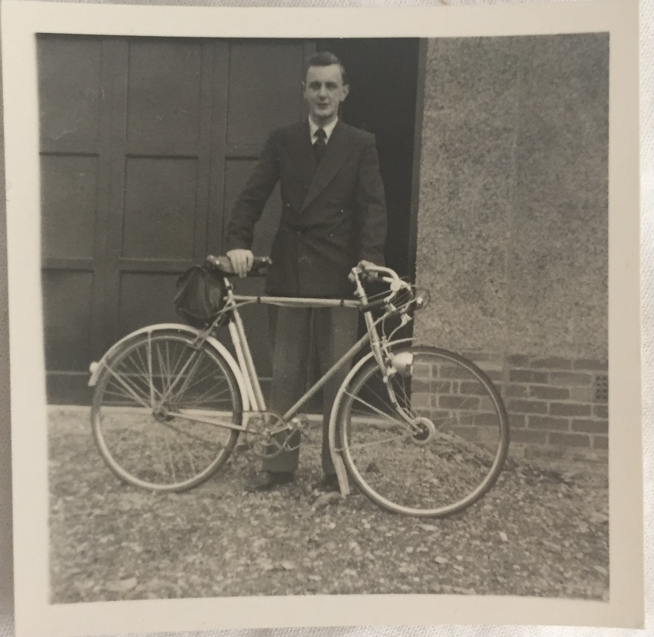
In the office I used to sit at a large desk like Scrooge’s and I had to keep the fire going. Mr Mason, my boss used to travel a lot and when he was out I used to take one of his expensive cigarettes from the box in the office which were from the brand “Passing Cloud”. They were very smart cigarettes, and unlike most brands were an oval cylinder, rather than round. I earned 7 shillings and 6 pence a week then – about 35p in today’s money – not a lot for very hard work. My desk was very high with a high stool and my job was to print off bills and invoices using a very old fashioned water printer. It took two hours to make a print. One of the first things I bought with my wages was a bike, I was so proud.
Me with my new bike – proud as Punch!
I was really unhappy with my wages so I started to look in the paper at the situations vacant pages. I saw this job which was my best job ever, Hunting & Sons and I was hired at £8 a month to be an office boy. There were two of us, me and Ronny Guymer, the best years of my working life. It was one of the biggest shipping companies in Europe in those days. All their ships ended in “field” e.g. “TyneField”. They looked after their workers too, with a profit linked bonus twice a year in June and December. I only started to work there in the October and I still got a bonus of £50 at Christmas, which was an enormous sum for me. I wanted to buy my mum a television set since I wasn’t paying board then so I tried to make it up to her but she wouldn’t have it, she put it into my savings.
When Ronny left, he was replaced by Brian Dixon who became one of my best mates and this was the start of my working life mischief! We had to take all the post down to the Post Office for the last post at six. We were often the last to leave and we used to get bored waiting so quite often we would turn the lights off in the office and play hide and seek. One day we played for too long and missed the last post so we had to go to the central post office, fortunately they took the post for us. It was a close call.
Because we were a shipping company we got many letters without stamps and used to have to pay the charges usually 5d, so we used to write “5d” letter charge in our petty cash book. Brian and I looked after the petty cash float for postage which was 5 shillings. Sometimes we used to be really bad and take 5d and bet each way on the horses. One morning we got the call to take our petty cash and book to be audited. We were quite scared because the book didn’t balance so we had to go around borrowing cash from people. We took the book and cash to be inspected and then afterwards returned the cash to the people who we had borrowed from, safe until next time, phew!
Tanganyika got independence and in the post came this letter with an envelope covered in the most magnificent stamps. We took it to the toilets and soaked off the stamps because we fancied sharing them out. After we had peeled off the stamps we decided to get rid of the envelope which we had torn up, down the toilet, but it was too thick to flush so we drew lots to decide who should put their hand down to clear the blockage and I lost so I had to roll my sleeves up and put my hand down while Brian kept flushing until it was all gone.
And that wasn’t all either. In the office we had a large, mobile, phone box. We used to use this box as our trial of strength. Both of us would get inside the box and fight to see who could last the longest in there. It was no-holes barred, so whoever got a hold on “you know what” first, they generally held on and won. We used to do this about twice a week and it was of so much interest to the lads in the office that they used to bring sandwiches instead of going out for lunch and watch. They loved it!
There was also this older bloke called Mr Milligan, a cashier, who was a bit stuffy and didn’t like us younger ones. One day he was bending down to find something in a low cupboard. His bum made a lovely target and Brian pulled out a ruler and began to charge as if to slap him with it. Everyone was watching and waiting for the impact and I guess, the reaction. But just as Brian got near, I held the door open and Brian swept out, ruler in hand with Milligan was none the wiser. The whole office was in hysterics
A little while later, the company decided it needed a commissioner to open the door for guests. He was a retired petty officer and was quite nasty to us. He would sit at the door and one day Brian whacked him on the back of the head and he chased us. We ran past but he almost ran into the MD who was just coming in. We got away with it but he received a final warning and he was told that if he did it again, he would lose his job. We gave him a wide birth after that.
Another way in which Hunting & Sons treated their staff well was that some office staff went to each launch of a new ship. You had to wear your best clothes but you were allowed on to the platform during the launch. We weren’t allowed to go to the posh evening do but were allowed to mix with the dignitaries, enjoy a lavish buffet lunch and champagne, not bad at all. Also those of us who had passports were sometimes allowed to fly out to Europe with a relief crew and sail back. One day I flew out with a crew on a Dakota to Hamburg to sail back on the “City of Newcastle”. It wasn’t like modern planes. The Dakota had no air conditioning, it was a cold place to be. The company used to give the officers money in hand before they flew. This was a bad idea since many of the men got drunk on the plane and refused to sit down and put their seatbelts on as we came into land. As we landed at Newcastle on return, the police were waiting and arrested some of them. I don’t know what happened but they probably were fined at least.
I was studying for my ICS exams (Institute of Chartered Shipbrokers) and as part of these I had to spend time on a ship at sea. On the Saturday I was due to join a ship in the Isle of Grain in London, my dad came down with me because he had managed to get tickets for us to see England v Scotland at Wembley. So in the afternoon I watched one of my favourite players, Duncan Edwards score and in the evening I caught the train out to the Isle of Grain. When I arrived after a long walk from the station in pitch black I was met by the officers of the ship in full dress to meet me. They had stayed aboard on a Saturday, quite a sacrifice because the Superintendent of shipping for the company was also called “Bell” and they thought I was he! I was popular though because I bought booze and cigarettes from the crew and they were pleased with the currency. At the end of the week I went home and sat my exams. I failed first time but passed second. So I had letters after my name – Ian Bell M. I.C.S.
After I finished my National Service I went to work for my dad’s company. My dad and his partner owned “Newburn Cordage” making string, baler twine, cords and ropes. The day after I joined, William Terrals another rope manufacturer tried to take over our company, but in a surprise move they themselves were taken over by British Ropes. Eventually too we too were taken over by BR. If I had known that was going to happen I would have stayed with Huntings but hindsight they say is a wonderful science.
Although I was the boss’s son there were no favours. I had to learn the job from the shop floor. As part of learning the ropes (no pun intended) I had to take a turn at many jobs including the stores. But two weeks after I joined my dad went into hospital for an operation. His partner Mr Brown, was good to me and said:
“Right you manage the office and I will do the rest.”
In those days we worked Saturdays as routine but I had to work on Sunday mornings too. Each Sunday morning I went I went into the office to do the time cards for all of the men and women. It took me from about 9am to lunchtime.
By the time 1963 came around, things had changed we received an offer from British Ropes. My dad, Mr Brown and his son Milburn and I had a meeting to decide what to do. The situation was clear. British Ropes almost had a monopoly on the rope manufacturing business in the UK. They were so big, they could decide the price of the raw materials such as sisal from abroad. If we had not accepted their offer they could have squeezed us out of business eventually, just by cutting their profit margins in our sector. We accepted their offer and I was given a job at British Ropes , Sunderland. But it’s like they say, oil and water don’t mix. Newcastle’s oil and Sunderland is water! I never got asked to join in with anything and never felt comfortable at all. They asked me why I didn’t turn up to socials, but I had usually never been asked, it felt bad. I was almost made redundant so I joined the union. It was really interesting, but those of us who had joined the union all got offered jobs. I am not saying they were frightened, but I didn’t lose my job. That was very important to me then because by this time I was married to Pam and we had a young son, David.
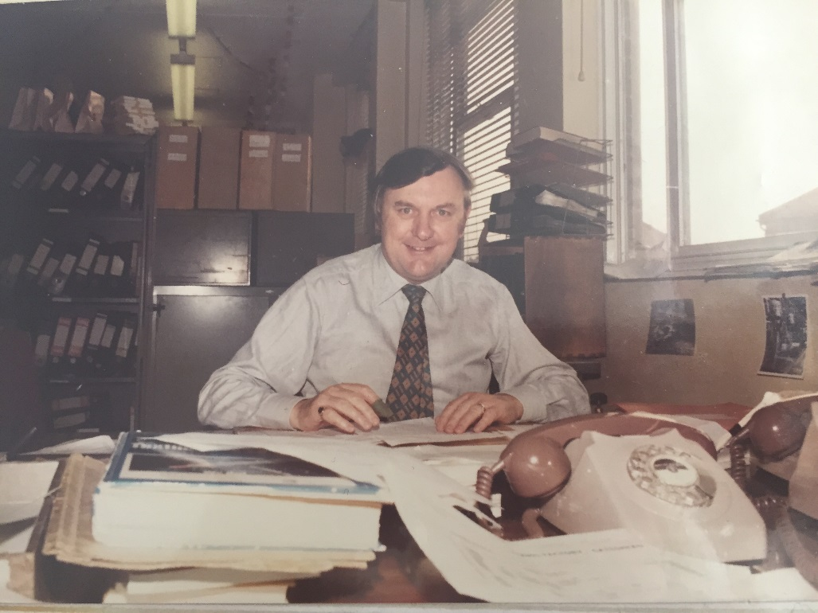
I carried on working for British Ropes for a while but I decided that I was unhappy and somewhat bored. Every day I was stuck in the same rut and I wasn’t using my brain so with Pam’s backing I decided to apply for a job with Norflex. The job was a “development manager” and I made such a mess of the application that I wasn’t surprised when two weeks passed by. Then I got this call from a recruitment agent in Newcastle who told me that the MD Richard Beck remembered me and wanted to interview me. Well, they offered me the job but the first salary offered was only the same as my current job, so I held out for more. They gave in and offered me a company car too! Now British Ropes surprisingly, didn’t want to lose me so they offered more too, but I knew I wanted a new challenge. I made sure that before I left I had all my contacts because I knew I would need them in my new job.
A proper captain of industry!
As business development manager I had to develop Norflex’s new offering in the twine and rope trade. Until we started to manufacture packing and baler twine we had to buy supplies in, I made a contact in Portugal with a company called Sicor and visiting them with our financial director we did a good deal. I used my contacts from my job at Bridon and within a year had managed to gain many major contracts for twine and string in the newspaper industry, Bridon’s biggest customers. Things went well with Norflex until the advent of SKY TV. Their main work was land drainage and they wanted to be in with the chance to produce cable for the TV revolution. They needed an extra extruder to make cable but didn’t want to put in more capital investment. They decided to come out of fibre altogether and use the machinery and staff to make cable for TV. I was offered a job at Horcastle, Lincolnshire as their office manager.
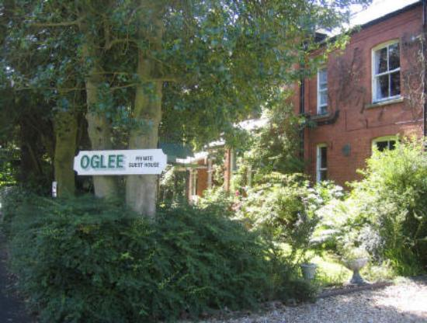
We didn’t relocate, instead I used to travel down to Lincolnshire leaving at 5.30 am on Monday and stay most of the week. I used to stay at the OGLEE guest house in Woodhall Spa, run I think by a religious family since the letters stood for: “Our God Loves Each and Everyone!”. It is still their today taking in travelling workers and holiday makers alike. To tell you the truth, I didn’t enjoy the nights away. Woodhall Spa is lovely in season, a good place to walk and all that, but in the winter after 6pm the darkness closes in and there is nothing to do. The town especially at those times seemed to be filled with people “waiting for God”. I was made redundant because it was costing the company a lot of money and I was not prepared to relocate to Horncastle.
After Norflex, six weeks without a job was enough for me. I didn’t like being at home and kicking my heels. I managed to get a job with a company working out of Stratford in London with Kendon Ropes & Twine still working with string.
I became a pioneer of what has become known now as remote working. I used the dining room at home as my office. I had my phone (not a mobile) and my fax and my card index file with all the information I needed. I never used a computer in my life, never needed one. I was quicker with my card index than those people who had to use a computer to find information. They would click away and in no time I had my card and would read out to them. In a race I would have been victorious. Also so many times the computers went down in the main office, and I was the only one still working through it all. I stayed in my home office during office hours, nine to five with perhaps a small peak at the TV when the cricket was on!
Towards the end of the nineties I started to get a little disenchanted with the attitude of some of the younger workers. I suppose looking back as I write this, perhaps I wasn’t as responsible at first when I was young either. Nevertheless, they caused me problems all the time. Newspaper twine had to be delivered on Fridays’ for the newspapers over the weekend. I would call the offices to check that everything was OK. The staff would reassure me but then all too often they hadn’t done the job properly. I was under pressure for their mistakes. So in 2001 when I was 66 I decided to retire, much to the relief of my family which by now had expanded to include my two precious grand-daughters, Vicky and Jess. They could now talk to me during the day as I was no longer in purdah. Pam was relieved too since she had access to the ‘phone and could have a proper dining room back to do entertaining including Sunday lunches for all the family.
But that isn’t the end of my story, there is a good way to go yet.

5: The loves of my life – wife and family
I cannot get to my love, if I would dee.
The water of Tyne runs between her and me.
And here I must stand with a tear in my 'ee,
Both sighing and sickly my sweetheart to see.
Oh, where is the boatman, my bonny hinny?
Oh, where is the boatman? Bring him to me.
To ferry me over the Tyne to my honey.
And I will remember the boatman and thee.
Oh, bring me a boatman, I'll give any money,
And you for your troubles rewarded shall be.
To ferry me over the Tyne to my honey,
Or scull her across the rough river to me.
“The Waters Of Tyne” a traditional Northumbrian Folk Song

I guess it all goes back to the talk my dad gave me before I went into the RAF: Well son, there’s good women and there’s bad women. Well I know what he meant now, well at least about the good woman I was lucky enough to end up with. I have been married to my Pam for 53 years and we have two lovely children and our precious grand-children, but it wasn’t as straightforward as it might seem getting to that point, especially as I have known Pam almost all of my life.
While Pam and I originally met in the Church Choir it was many years before I had sense enough to realise that she was the woman for me. My first date I recall was a blind double date with my work friend Ronnie Guymer. His date was as I recall quite OK, but mine was cross eyed. Needless to say, there was no second date.
I guess I started the dating game seriously, quite late. I was a mummy’s boy, I don’t mean that I lacked masculinity; just that my mum never wanted to let me go! She certainly felt threatened by Pam because she held on to a Christmas card which a friend, who was a girl had sent me and each Christmas she used to bring it out and pointedly comment on it. I think she was trying to scare Pam away, but my girl was made of sterner stuff and a match for my mum any day.
I didn’t have a lot of girlfriends before Pam and I wasn’t serious about any of them and that’s the truth. There was this one Dorothy I dated for about a year and I realised she was taking things a bit too seriously for my liking when she took me to meet her mum and dad. Well, I knew I had to do something and quick. So one evening at tea time with her and my mum and dad I said:
“I have got something to tell you, I don’t want to go out with you anymore”
She burst into tears, my dad told me to go outside for a bit and get myself sorted and he ended up taking her home. I never saw her again. She did call on the ‘phone a couple of times and asked if we could get together again, but I said “I don’t think so, no”.
Besides that there were only a couple of girls I recall. One was from Scotland who used to visit at holiday time but that was really only a flirtation, but there was also, sadly the one that “got away”. I went out to a dance with Jackie Gilchrist and his girlfriend and met a girl, she was lovely, and I planned to ask her out but never got around to it, I don’t know why, perhaps it was fate. The next thing I knew she was killed in a car accident. I guess sometimes things not meant to be but I have no regrets except that the poor girl died too young.
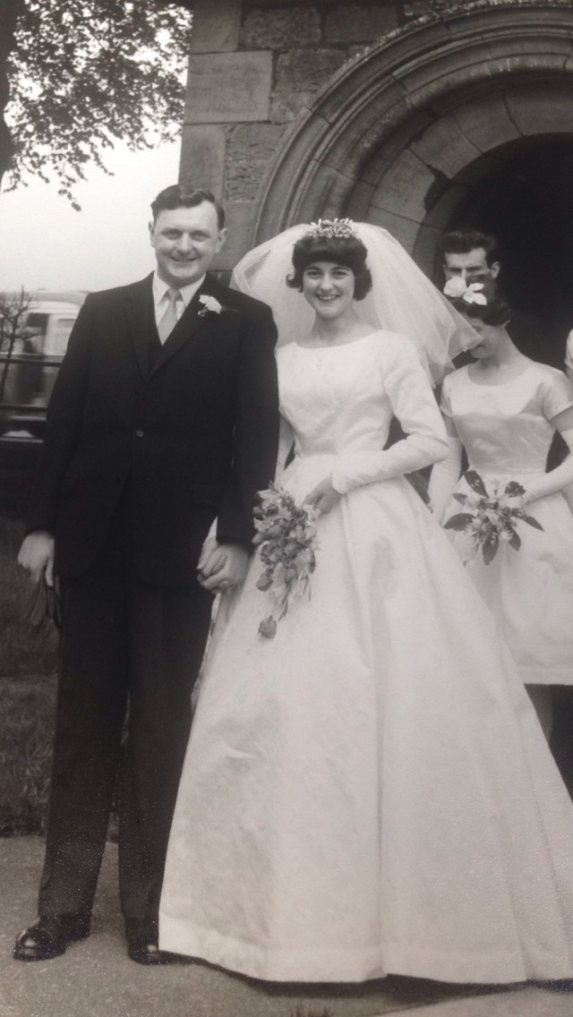
I met Pam through the church choir. Pam was 17 and we went out for a year before we became engaged I asked her to marry me in Emmerson’s club when she was 18 because she was the only girl for me. We went to buy a ring and pam chose a lovely solitaire, we had a party, but barely told anyone, I don’t know why, but it upset a few people that we didn’t tell too many. I used to go to her house for supper on a Sunday evening and I remember her dad used to give me chips! When I visited in an evening I got thrown out of the house at 10.55, just in time to catch the last bus at 11.03 home. It was known as “the miner’s bus” because it took the miners to the evening shift. They were good to me, they would never let that bus leave until I had got on. Mind you, they used to tease me because they knew I was courting.
We waited a while to get married but 1962 was a popular year for getting married amongst me and my friends. I felt like I was turning into a professional best man until it was out turn and were wed on 2nd June at Throckley Church. I was a mature 26 and Pam, was my child bride at 20.
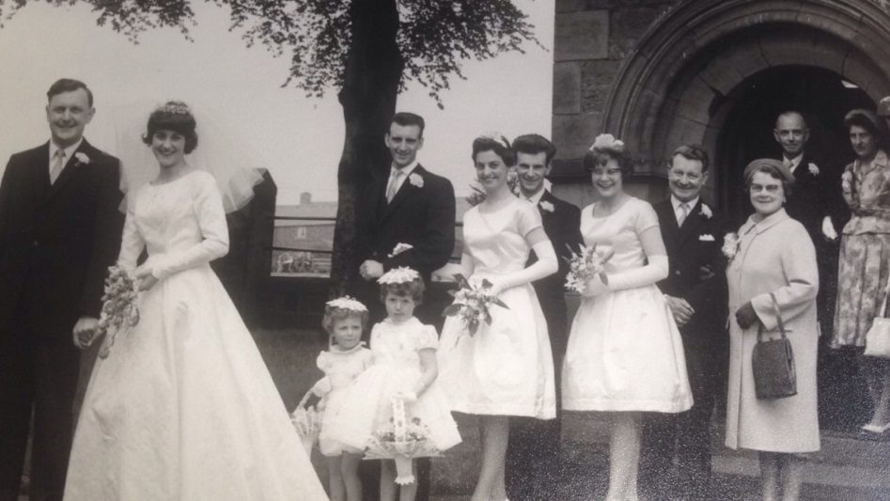
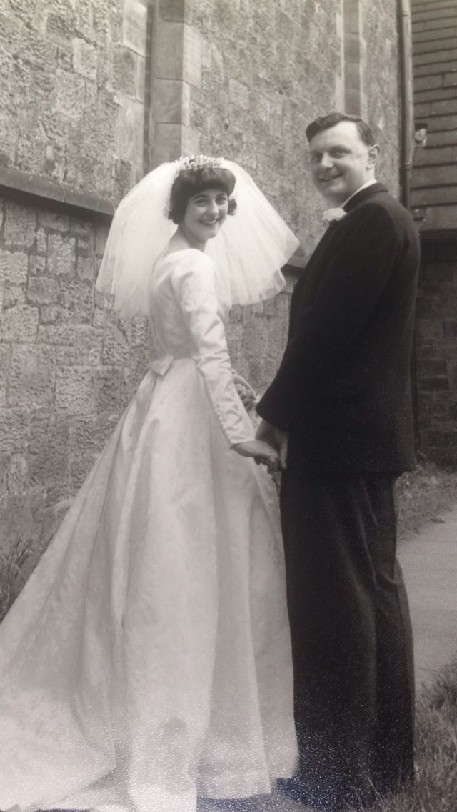
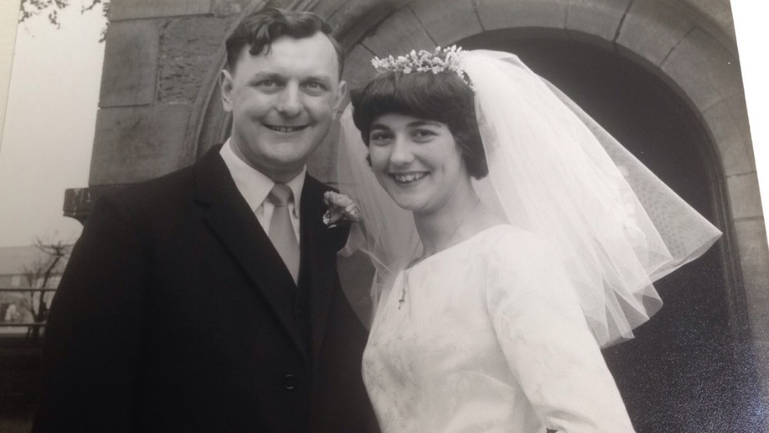
She had a lovely white dress and had borrowed her sister’s tiara, but all I remember is she looked beautiful and I was bowled over.

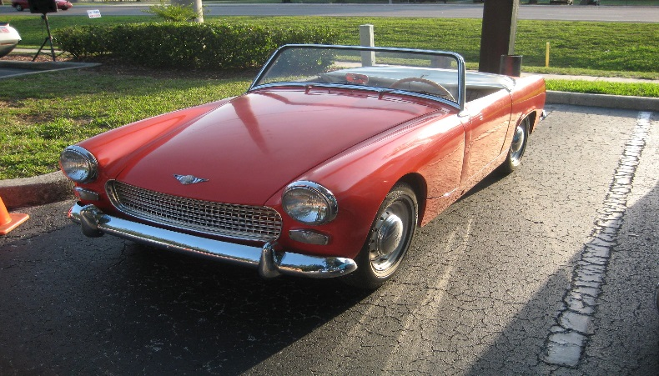
At the time we got married I had been saving all of my bonuses from Huntings to buy an Austin Healey Sprite. They cost £700 and I nearly had enough money. But it was a choice rally between the car or a honeymoon and a deposit for a house. Good sense unfortunately prevailed but, we did have a honeymoon to remember.
The car that never was mine, a 1962 Austin Healey Sprite
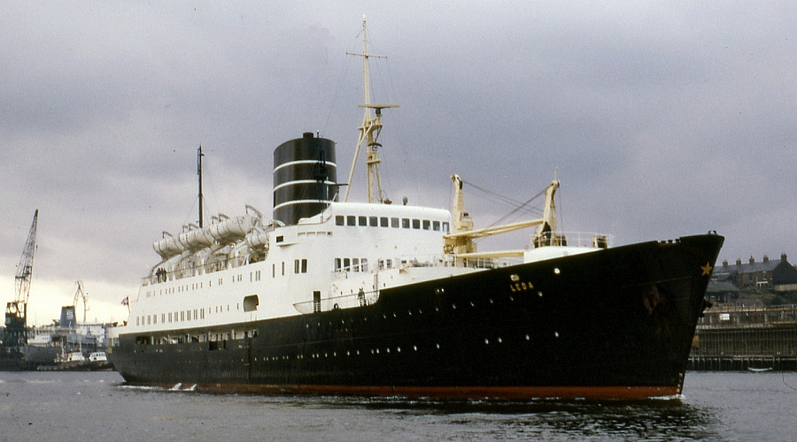
In the 1960’s it was still relatively unusual to go abroad for a holiday or honeymoon and we really pushed the boat out – quite literally, we sailed to Norway for a 10 day holiday on the Hardanger Fjord. It cost £47. 7/6d which was a tidy sum in those days. We sailed out from Newcastle to Bergen on the Leda (pictures below). It was our wedding night and we ended up with twin beds! During the night I got up to go to the toilet and it was pitch black and I banged my head on one of the bulkheads.
In the morning, Pam was more worried about the mass of confetti on the floor and cleaning it up than she was about my cut head!
We went from Bergen to Voss on the bus and boat, a long journey to the hotel. I remember Pam looked fantastic in her orange coat and hat. When we got to our room the curtains were closed and so I switched the light on and the light fell off the wall. I had to call the manager to tell her that I had damaged the fittings!
This little mishap was not typical of our stay though. Our balcony overlooked the Hardanger Fjord and it was lovely, full of flowers. The dining room had enormous windows so that the whole aspect overlooking the Fjord was glass and gave a magnificent view. The food too was out of this world. Breakfast often included fish freshly caught in the fjord, cheeses, and meats. I felt it was like heaven, all my favourite foods, but Pam who didn’t eat fish & didn’t care for cheeses was less impressed.
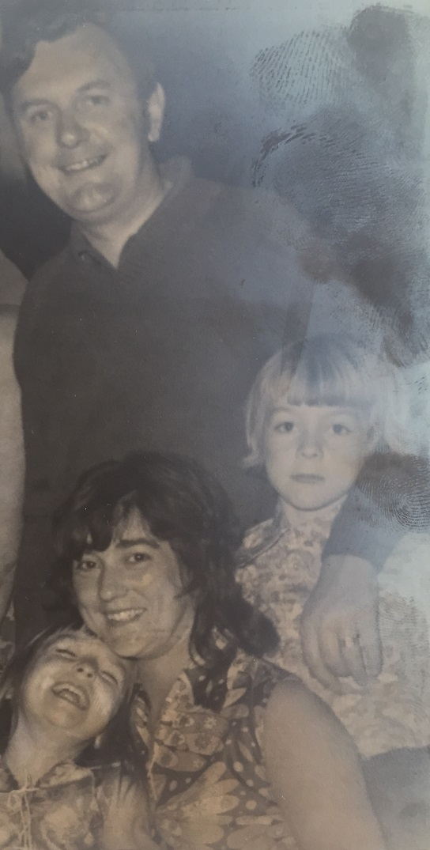
Now, Fjords are famous for several things and one of them is their depth and the coldness of the water. Like the Scottish Lochs they are drowned, deep. Valleys made by the ice of glaciers. Pam and I took a rowing boat out on to the fjord several times during our stay. Neither of us could swim and were probably ignorant of the danger should we have fallen in. One day we had a porpoise come alongside us and breech, it was lovely. I liked to fish and one day I must have hooked an eel or something because it pulled us and the boat along, it was quite scary. The hotel had a motor launch big enough to take most of the guests in it, we went down the fjord in it, wonderful. We travelled home on the Venus and began our married life living with my parents until our brand new home here was completed. A good way to start our married life.
We moved a few months later to our current address followed soon after by the birth of David our son in 1964 and Lesley in 1967. The walls of this house have seen many a good time, party, celebrations and the warmth of a close knit family with only the smallest number of mishaps, of which more later, but we have had a good life together and I am thankful for what I have experienced and had.
My family has always been the centre of my world and with time the circle of close family has grown. On 23rd September 1989, Lesley our daughter married Peter Henry Baird at St Mary’s Church. As I was working away from home all the wedding arrangements were left to Pam and she did a fantastic job. The honeymooned in Acapulco, Mexico. They are a happy couple and have presented us with our two grand daughters Victoria born in 1996 and Jessica, not long after in 1997. David too has been lucky and found a life partner in Heather Lamb and has a readymade family in her two children, Nathan and Josie. We all ge on so very well and I consider myself blessed.

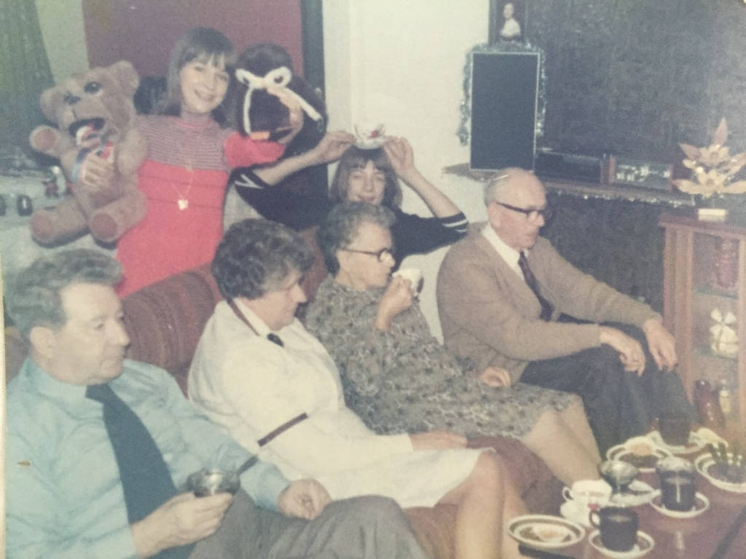
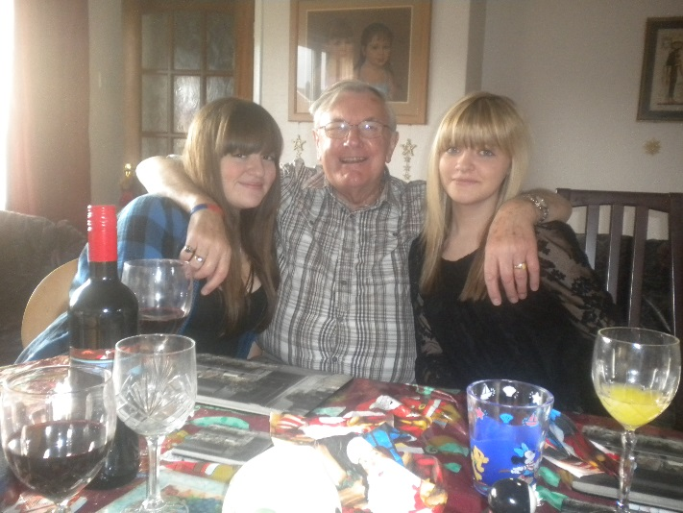
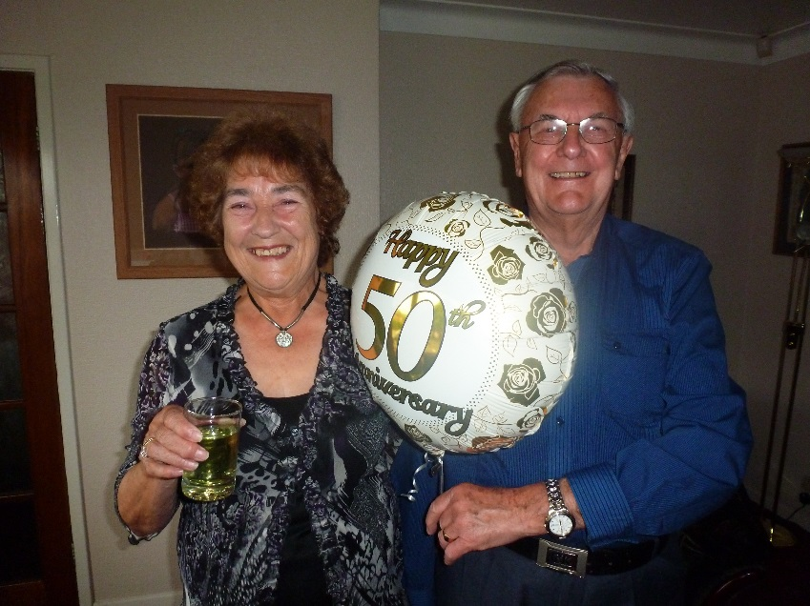
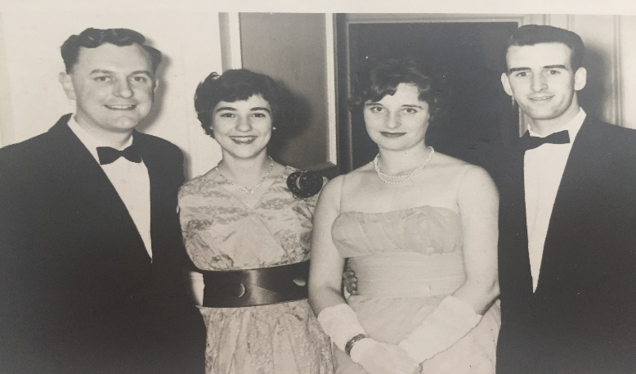
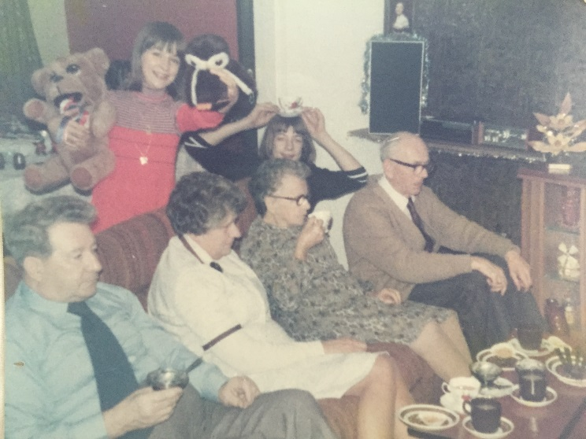
6: We’re all going on a Summer Holiday..

We're all going on a summer holiday
No more working for a week or two.
Fun and laughter on our summer holiday
No more worries for me or you
For a week or two.
We're going where the sun shines brightly
We're going where the sea is blue
We've seen it in the movies
Now let's see if it's true.
Everybody has a summer holiday
Doing things they always wanted to.
So we're going on a summer holiday
To make our dreams come true
For me and you!
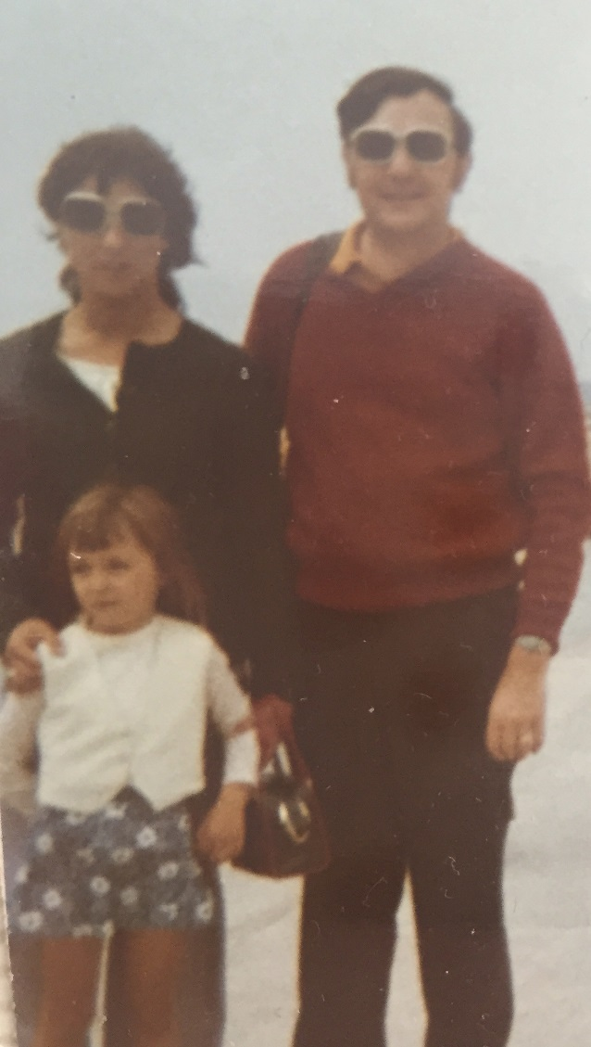
Holidays have always been important to us. I worked long hours, so the chance to be with my family for a week or two without any interruptions has been a priority. Latterly, those holidays have been a chance to for Pam and me to reward ourselves for all the hard work and sacrifices we made when we were younger.
I remember particularly our early trips abroad when we took the children to the Balearics, first to Ibiza and later to Majorca. I particularly remember the latter because David managed to lock himself in the room and a waiter with the agility of an acrobat climbed on to the balcony at some height and sorted it out.
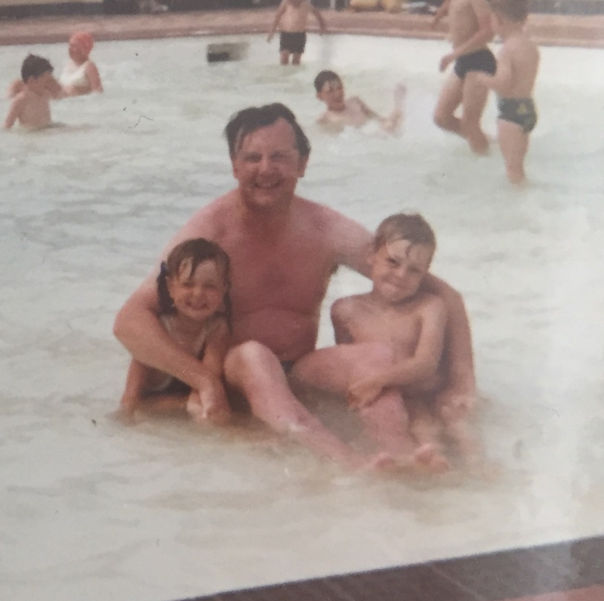
We didn’t always go abroad for our holidays, though travelling down to Devon from Newcastle was a feat not far short of a military campaign! I loved my car so the kids had to be we well fed and watered before we set off, because there was no eating and drinking in my precious car! We always set off on Friday evening and I drove through the night to miss the famous tailbacks down to Devon. A couple of times we also gave the Motorail from Newcastle to Newton Abbot a go. It was a 12 hour journey and we always arrived very early in the following morning and had to sit in the car waiting for anywhere to open. In the summer of 1976, which was particularly hot we used the motor rail service and it was so hot we couldn’t sleep.
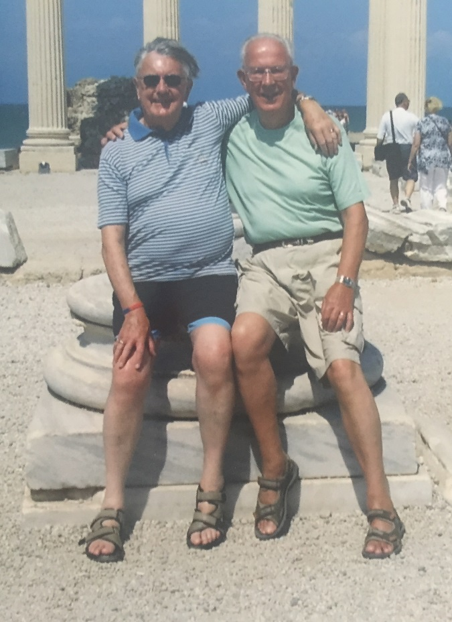
If we didn’t go to Devon we took a trip north to Scotland including Pitlochry, Oban and Edinburgh. This was a memorable holiday for all the wrong reasons. When we were in the far North near Oban, Pam was slicing buns for hotdogs (a regular item in our picnics – no boring sandwiches for us) and she sliced open her hand. Lesley screamed and ran into the car, a woman came to help and bandaged up Pam’s hand but all David could think about was that the buns were wasted because they were covered in blood. Pam seemed to develop car sickness so when we were in Pitlochry, I left her taking the kids to see Jaws, yet more blood, as if we hadn’t seen enough during that holiday already.

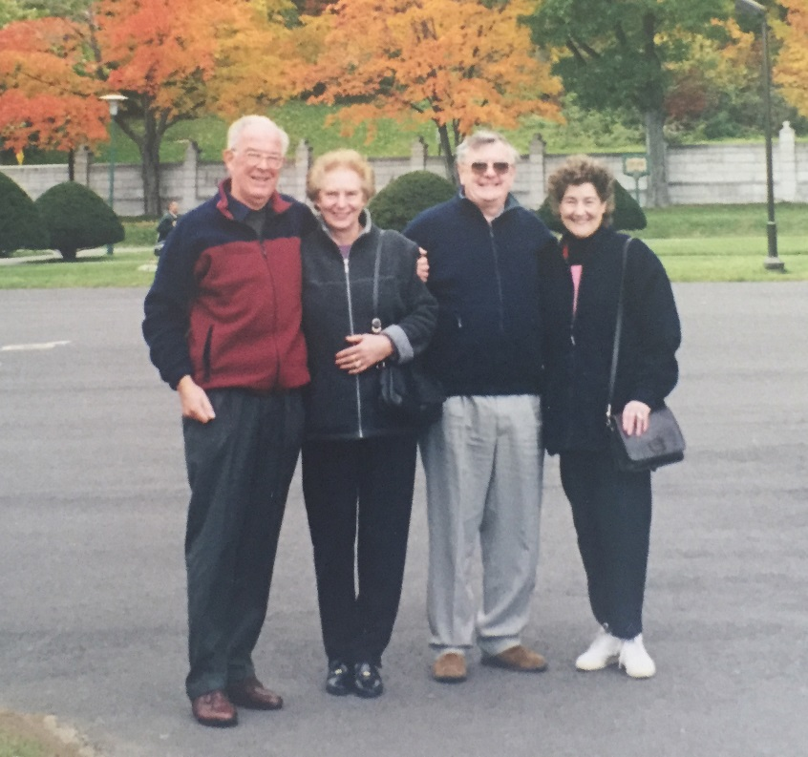
As we shed our parenting responsibilities our holidays became more adventurous and often accompanied by Peter and his wife Joyce, we have travelled far and wide. We are very lucky and have had some rally exciting experiences, some funny ones too. Peter used to call me “Lord Bell”. At one hotel there were some Americans at our table and they took this seriously. We wound them up about it the whole meal but decided to tell them the truth afterwards. They were a bit disappointed but saw the funny side after all. On cruises, we have sat at the Captain’s table no less than three times.
Once during a holiday in Canada, we were shown our room and inside was a hamper full of “goodies” with a label marked “with compliments”. We invited Joyce and Peter to join us and we ate quite a lot of it. We found out later that it had been delivered by mistake, surprisingly the intended recipient never complained about the error.
Peter, Joyce, Me and Pam in Canada
For our silver wedding we went on a Nile Cruise and saw the Pyramids. The whole experience made us feel special. It began in Heathrow’s private lounge where Vivian Davis of the British Museum’s department of Egyptology came to give us a talk on what we would see and its significance. During the cruise down the Nile, like characters out of an Agatha Christie novel, we were offered Egyptian wine which has to be the most disgusting drink I have ever tasted. I thought I was being poisoned. The problem isn’t the grapes or the methods but the fact that the shortage of fresh, clean water in Egypt reduces the quality of every drink.
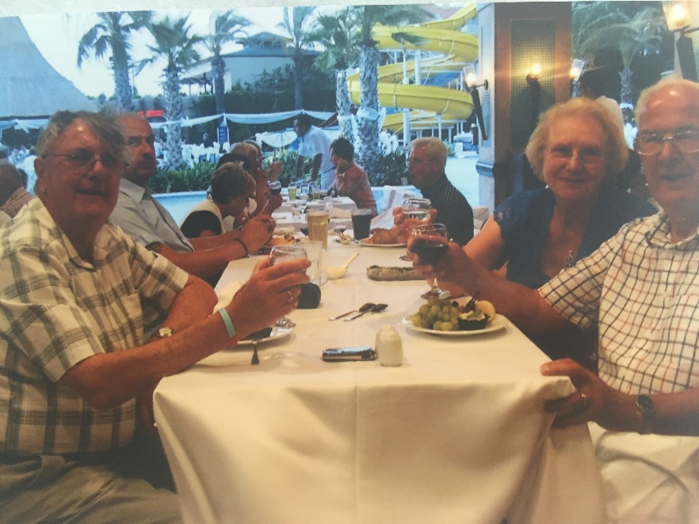
We have also travelled to the Far East visiting at various times, Hong Kong, Singapore, Thailand Bali and Bangkok. It was in Thailand that I encountered “Lord Charles’ Bespoke Tailor”. The only connection with the Lord Charles ventriloquist dummy of Ray Alan fame, was that they took me for one! Lesley’s wedding was about to happen so Peter and I decided to get made to measure suits for the evening reception. I went to Lord Charles’ tailoring and they measured me, one day later I went for a first fitting and 48hrs later it was ready to try on. As I arrived the tailor said he had thrown in a matching tie and shirt. I went to try only the suit on in the fitting room which was lit by one solitary, weak light. The suit was an excellent fit and I was pleased. But as I put the suit on to wear before Lesley’s and Peter’s evening do, in bright daylight I noticed that there was a huge iron burn right across the seat of the trousers and as for the shirt and tie combo, the buttons were crooked, the sleeves were on upside down and the colour in the tie ran as it got hot. Needless to say they all went in the bin. Needless to say, if I ever go back to Thailand I shall look that fella up and give him a piece of my mind. What rubbed salt into my damaged pride was that Peter’s silk suit was lovely!
We have also been lucky enough to cover the Americas from the tip of Canada right down to Santiago at the southern Tip of South America. We have even been to the Falkland Islands as well as Rio, and the Caribbean. We count ourselves lucky in that we were in that first generation where travel became accessible to the many rather than only the few. Our parents couldn’t have even dreamed of seeing the things we have seen or doing the things we have done.
Of all the thirty or so places we have travelled to in the USA (Peter tells me this is the number he has a map with a pin for every destination) the best has to be Memphis and Las Vegas. At Memphis we went to the “Grand Ole Opry House” to see a country and Western show on the stage where all the major country stars had performed over the years.
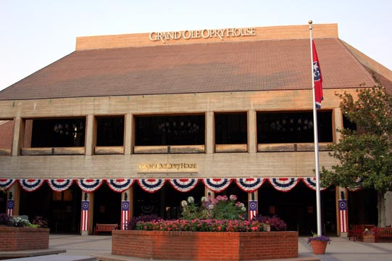
But it was Graceland which was the highlight of the trip for us. We are of the generation which grew up with Elvis and his music. He was part of our lives and only a few months older than me. We enjoyed the chance to see his home and the Elvis museum collection too.
While we like the music of Elvis a lot, we also enjoy Tom Jones’ too. It was during one of his stints at Las Vegas that we were there too. I queued for over 2 and a half hours to get tickets to see his show. It was great, and we had good seats too, a table that was only two rows back and we had the best view you could imagine.
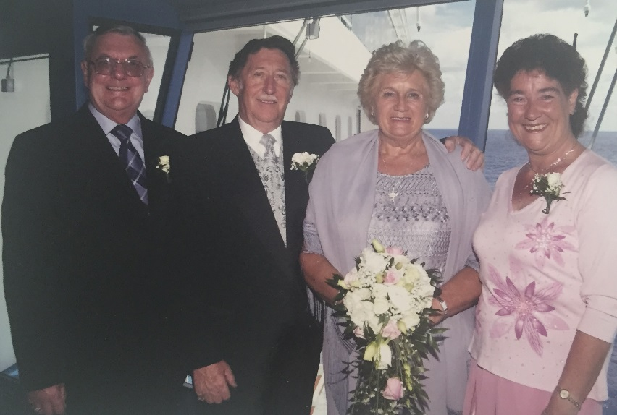
Perhaps the most unusual thing to happen to us while we were on a cruise was the request from another couple that we would be the witnesses to their marriage. We agreed too of course even though the request seemed strange.
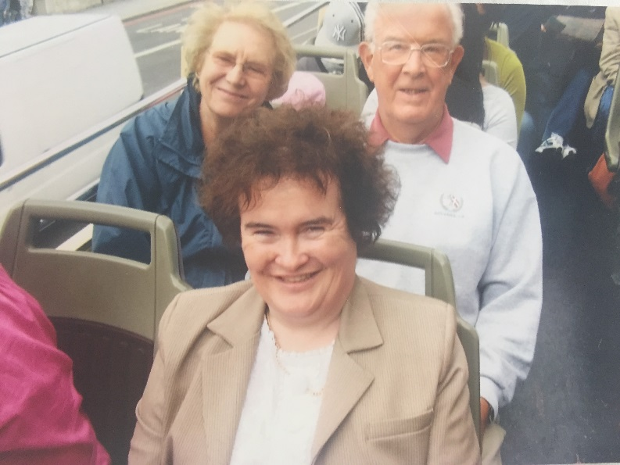
Not all my trips have been exotic ones. Every year a large group of us take a day out to York races. It usually includes a pub crawl with a difference, we play a different game at every pub: dominoes, cards and pool. We always ended up at the same Fish and Chip shop where they provided information about which boat had landed the fish we were eating, such care, great chips too! One time there were 27 of us to go through the turnstiles in York on one group ticket. Some of us were dying to go to the toilet and as the ticket inspector, a particularly small Asian-looking bloke tried to count everyone in this throng so he staid “Oh bugger it!” and opened the turnstile and let us all through!
Another unexpected highlight was seeing Susan Boyle on a London Bus. She was being managed by her team, but even so she allowed us to take a picture of her as a momento, lovely lady.

7: Animals, bananas and near-death experiences.

Have a heart that never hardens, a temper that never tires and a touch that never hurts
Charles Dickens

I laugh a lot. Probably because life is funny. I can’t remember all of the events in my life which have made me or others laugh but as I approach the end of my autobiography, I want to set as many of these amusing and sometimes poignant experiences down, to leave you with a smile and something extra special, just for you.
Well we weren’t big on pets, so we made do with a budgerigar named Bluey. I remember though, Lesley was desperate for a dog so much so that she had an imaginary one….well one day we had the answer to all our problems of Lesley’s demand for a dog, a tortoise called Pippin! Pippin appeared one day as if from nowhere. We had him for a few years and hibernated him as you should, then one spring I went into the garage to get him out and I knew something was wrong. He was laid out flat on the box and didn’t smell right. My mum said, tortoises don’t move when they are asleep, you need to take him to the vet to see if he is still alive. I sat there in the waiting room in the vets in Newcastle and you can imagine what the reaction in the waiting room was. All these cats and dogs could smell the deadness and wanted to get at it. When it came to my turn the vet just took one look at the tortoise and laughed out loud and said:
“Well it’s a bit like a sketch from Monty Python……your tortoise is dead. He is an ex tortoise…has shuffled off his mortal coil”
I suppose we could have carried on, but he just confirmed for me what I knew already and charged me a fiver for the privilege.
But I do have a particular skill with animals which even Derren Brown would be jealous of, I can bring fish back to life. The event was a mystery and centred around our two goldfish called Tish and Tosh. One evening, while Pam was at church one of the pair jumped out of the bowl and I never saw where he went. When Pam returned we found the goldfish behind the china cabinet and he looked dead. Undeterred, I went to the freezer and pulled out two ice cubes and rubbed them on the fish who not only came around, but lived on for several years after that – there you have it, fish resurrection!
I wasn’t so lucky with turkeys or geese at Christmas mind. One year when I was still at home my parents were given a Christmas goose. Well it wasn’t a good gift and was bad, so we buried it in the garden without funeral rites! On another occasion we decided to buy a fresh turkey from a local supplier but on Christmas Eve, found it had gone off. I went back to the bloke and told him and he offered me one he had put on the freezer. The problem was we had to let it thaw before we could cook it. So we had our Christmas Dinner at 4pm
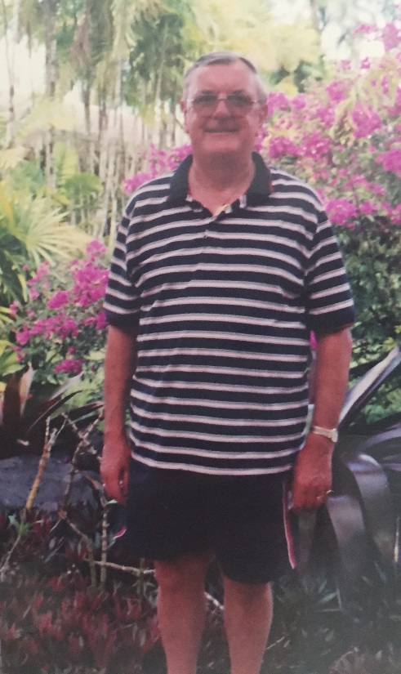
Knowing full well that all the family was due to come around for tea of cake, etc… we had just started our meal when the door-bell rang and our first lot of guests arrived for tea. Before we had finished lunch all the guests had arrived and we had to clear away quickly, wash up and set the table for tea. It was hard work trying to eat two large meals within an hour of each other….I felt very sick.
Everyone has their 15 minutes of fame so they say, well perhaps we almost did. During the 1980’s we auditioned for “The Generation Game”. Lesley and I went to this posh hotel in Newcastle and along with others we had to demonstrate that we had a whacky sense of humour which would make us entertaining on TV. As part of the audition we had to recall an incident when our partner had said something funny. I told the story that when Lesley was small and I wore very short-shorts on holiday she said out loud as we walked down the street:
Me in a pair of short shorts circa 1990…
“Dad, your tiddler’s hanging out”
You know that moment they call the tumbleweed moment when no one laughs and you want the whole world to swallow you up? That was such a moment. No one laughed and the production team just smiled an insincere smile. Needless to say, we didn’t get through to the second round. I never liked Bruce Forsythe anyway!
I mentioned earlier that I managed to survive a hut fire caused by an iron when I was doing national service, well I have had a few other near death experiences and one of these involved a giant, inflatable banana. I can’t swim as I think I have mentioned before. We were on holiday in Turkey and there was this big inflatable banana boat being towed across the bay by a powerboat. Loads of people were already on it and I tried to get on by pulling myself up by the handle but instead of me pulling up everyone else was tipped off. Pam and the others were on the beach doubled up with laughter as I tried several times and by the time I finally gave up I was out of me depth and way off shore. They had to give me a lift back in the powerboat!
On the same holiday we hired a boat to take us for a BBQ but his time I boxed clever, or so I thought, wearing several life jackets but when I went into the sea I began to drift and I went under the water and under the boat. Even with a life preserver I still nearly drowned.
I like to think of myself as reasonably public spirited. I have been a blood donor and I have volunteered to be a human guinea pig for medical tests including a new test in an MRI scanner. My experience with the MRI scanner felt like my third brush with death! As the test finished I got a dreadful pain in my chest. Well I have never seen so many people panic. They hooked me up to all kinds of machinery and did loads of tests even kept me in hospital. I don’t know what this says about me but generally they say the risks for gallstones are “fair, fat, 40, fertile and female” well, I might be a little round (Mind you it is all bought and paid for!) but I don’t suppose I will see 40 again and I would rather not have any truck with the rest, female indeed!
If I said that I was sober in spirit, then opinion amongst friends and family might well be divided. I love going to the club on Fridays but there have been a few occasions where I have become a little inebriated, usually at parties. One day I realised I had perhaps gone a little too far when I woke up the morning after the night before to find vomit on the bathroom ceiling. This event is still known in the family as the ICBM (Inter-continental, ballistic missile) vomiting and it remains one of life’s little mysteries to this day. I must admit I have no desire to repeat the experiment.

8: Last words
I should perhaps let those who know me best have something to say here but before I let them loose I want to add a few words of my own.
I have enjoyed my life so far and I am proud that I have been married so happily and for so long to my beautiful wife Pam. I love the fact that we are still so close as a family that we choose to spend so many family times together. The holidays, the Sunday lunches and Christmas. My lovely grand-daughters who gave me the opportunity to set my story down in words.
I am a happy man. I have loved my family, my friends, my work and so many experiences on the way. I wouldn’t change a thing. I am proud of my achievements, especially saving all of those people from the fire caused by my iron.
My philosophy of life is simple. I never want to say a bad word or even think about a bad thing about another person. When I look back I want to smile and enjoy the things which make me happy, not the things which make me sad, what is the point of that, I can’t change them can I ? But I can still make people happy now with this autobiography.
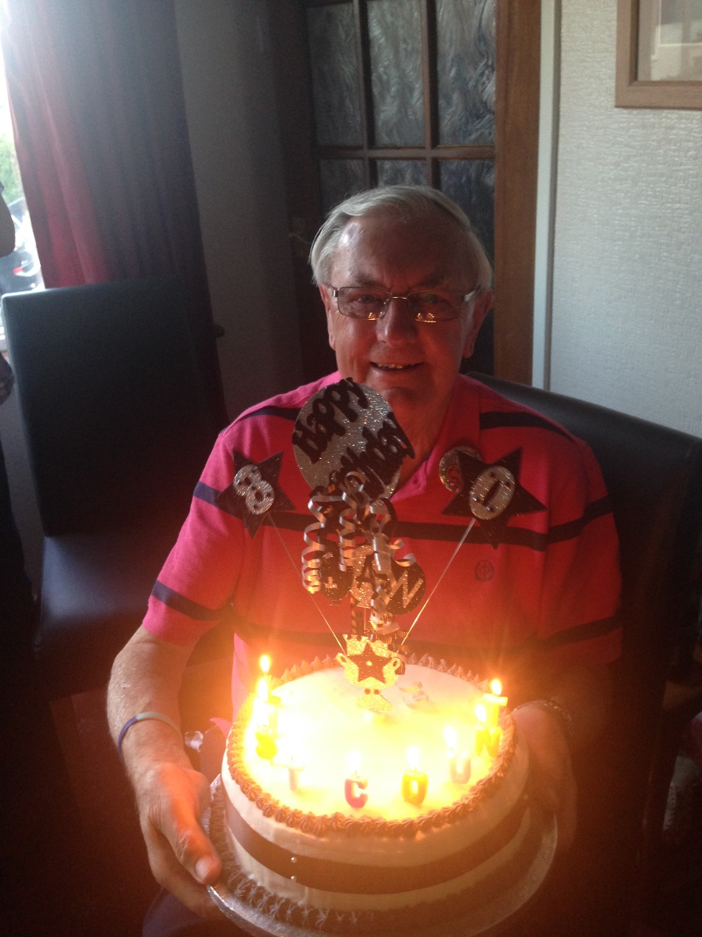
Even at 80, with a little Nivea and a feeling of being much younger in heart, I can smile and say:
“Grow old with me, the best is yet to come”

Ian Bell, 80 years young.
July 22nd 2015

